(a) Measures / scales for motivations for long distance hiking

**Article name: Appalachian Trail Hiking Motivations and Means-end Theory: Theory, Management, and Practice**

Gómez, E., Freidt, B., Hill, E., Goldenberg, M., & Hill, L. (2010). Appalachian Trail hiking motivations and means-end theory: Theory, management, and Practice. *Journal of Outdoor Recreation, Education, and Leadership*, *2*(3). <https://doi.org/10.7768/1948-5123.1043>

**Brief Note:** Using means end theory (a marketing tool developed by Reynold and Gutman in 1982

Attributes --> consequences --> values (participants talk their way through the laddering technique—qualitative)

**Measures:**

* The relation­ships between attributes, consequences, and values associated with the AT by its users.
* The BHS measured both demographics (e.g., gender and age) and usage patterns (e.g., hiker typology and time spent on the trail).

**Scales:**

* Benefits of hiking scale (BHS)-- a quantitative scale (instead of the laddering technique)
* A section of the questionnaire was designed to measure the relation­ships between attributes, consequences, and values associated with the AT by its users. Answers given were measured on a 7-point

**Tools:**

* A survey on Inquiste 8.0 using means end theory

**Article name: Appalachian Trail Hiking Motivations and Means-end Theory: Theory, Management, and Practice**

Freidt, B., Hill, E. L., Gomez, E., Marni, G., & Hill, E. L. (2010). A benefits-based study of Appalachian Trail users: Validation and application of the benefits of hiking scale. *Physical Health Education Nexus, 2*(1), 1-22

**Measures:**

* The benefits component of the scale explored the typologies of benefits sought by AT users; the typologies measured in this study were those identified by Driver (1998a; 1998b)—the improved condition (IMP), prevention of a worse condition (PREV), and realization of a psychological state (PSYC).
* A total of 30 items were used to measure Driver’s typologies of recreation benefits with respect to hiking on the AT
* 33 items were used to measure demographics (e.g., age, gender, household income, etc.) and use patterns (e.g., hiker type, time spent on trail, volunteerism, etc.)

**Scales:**

* The 63-item benefits version of the Benefits of Hiking Scale (BHS) is a quantitative, online survey instrument created using Inquisite version 8.0.
* The benefits section was measured using a 7 point, Likert-type scale where 1 = never / not applicable, 2 = very much not like me, 3 = moderately not like me, 4 = somewhat not like me, 5 = somewhat like me, 6 = moderately like me, and 7 = very much like me.
* One-way between-subjects ANOVAs were used to analyze the relationship between hiker types (i.e., day hiker, overnight hiker, section hiker, thru-hiker and multi-use hiker) and the dimensions of recreation benefits (i.e., the improved condition [IMP], the prevention of a worse condition [PREV] and realization of a psychological experience [PSYC])

**Tools:**

* A survey on Inquiste 8.0 using means end theory
* The data collected were analyzed using the Statistical Package for the Social Sciences (SPSS 15.0)
* Descriptive statistics were performed in order to get an overview of perceptions and demographic information from the respondents
* Confirmatory Factor Analyses (CFAs) were performed to establish the internal and external validity of the hypothesized constructs of recreation benefits, and Chronbach’s Alpha was used for the reliability analysis.
* The p-value of 0.05 was used as the criterion determining statistical significance among the variables for all analyses.

**Article name: Why individuals hike the Appalachian trail: A qualitative approach to benefits**

Goldenberg, M., Hill, E., & Freidt, B. (2008). Why individuals hike the Appalachian trail: A qualitative approach to benefits. *Journal of Experiential Education*, *30*(3), 277–281. <https://doi.org/10.1177/105382590703000311>

**Measures:**

* Means end theory: interrelationship among product meaning at three levels of abstraction: attributes, consequences, and values (Goldenberg, Klenosky, O’Leary, & Templin, 2000).
  + Attributes: key “product” attributes include the length of the experience, loca­tion, activities done while in the backcountry setting, and the number and nature of individuals in the group.
  + Consequences: positive consequences, or benefits, for participants completing a wilderness-based experience may include: companionship and camaraderie, acquisition of skills needed to function in outdoor settings, or increased environmental awareness
  + Values: self-esteem, warm relationships with others, self-fulfillment, and fun and enjoyment of life.

**Scales:**

* From data collected based on implication matrix, a hierarchy value map was created

**Tools:**

* The process of means-end data collection is a qualitative approach termed laddering (Reynolds & Gutman, 1988). In this study, this question­ing technique was completed through phone and face-to-face interviews that lasted approximately 10 minutes for each interviewee.
* a series of open-ended questions
* data were analyzed through LadderMap (Gen­gler & Reynolds, 1995). LadderMap is an MS DOS program that creates Hierarchical Value Maps (HVM) based on input.

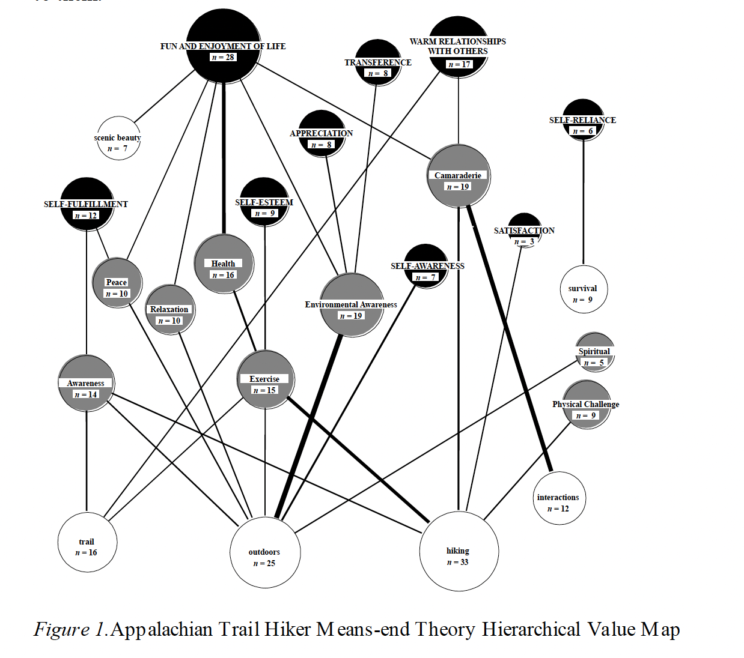

* The Hierarchical Value Map illustrates the strength of relationships between attributes, consequences and personal values found to be related to hiking on the AT. Attributes were listed in un-shaded circles, consequences were depicted in semi-shaded circles, and values were listed in completely shaded circles. The strength of the relationship between two items was depicted by the thickness of the line.

(b) Measures/scales for digital technology use (before, during, after hikes)

**Article name: Time on the trail, smartphone use, and place attachment among Pacific Crest Trail thru-hikers**

Amerson, K., Rose, J., Lepp, A., & Dustin, D. (2019). Time on the trail, smartphone use, and place attachment among Pacific Crest Trail thru-hikers. *Journal of Leisure Research*, *51*(3), 308–324. <https://doi.org/10.1080/00222216.2019.1680264>

**Measures:**

* Research Question 1: To what extent are smartphones used by recreationists when in a remote setting and in town?
* Research Question 3: What is the relationship between frequency of smartphone use and place attachment?

**Scales:**

* an additional 20 individual measures of smartphone use were included to assess how frequently, on a scale from “never” (1) to “sometimes” (3) to “always” (5), thru-hikers used various smartphone applications. These statements asked about the frequency with which thru-hikers used each app on the PCT (remote setting) and in town.

**Tools:**

* on-site self-report questionnaire employing Qualtrics software, uploaded onto a first generation iPad, iPad 2 s, and an iPad mini via the Qualtrics Mobile Survey application.
* Questionnaires were administered in three phases in order to capture PCT thru-hikers during early, middle, and later stages of their thru-hike
* The questionnaire was divided into three sections: demographic information, smart-phone usage, and place attachment.
* additional question was added that measured thru-hikers’ self-reported average daily smartphone use, all uses with the exception of taking pictures

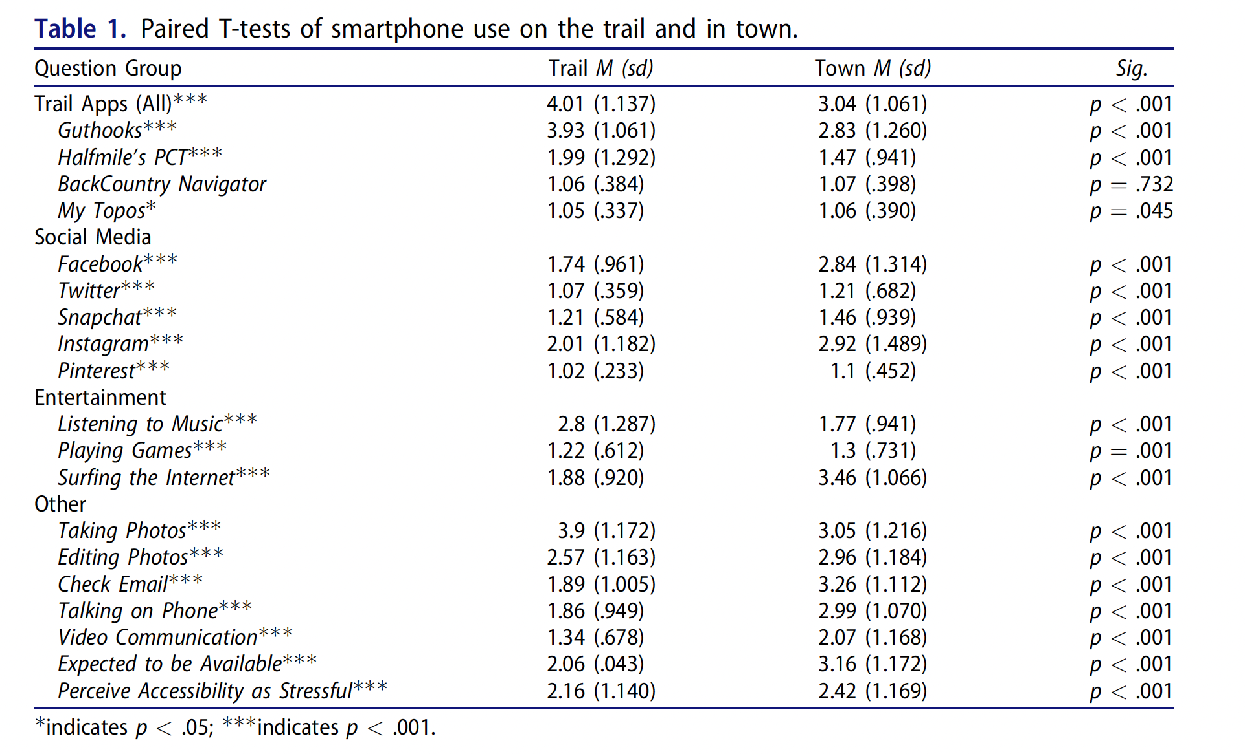

**Article name: User Requirements for Location-Based Services to Support Hiking Activities p.189**

Gartner, G. F., & Rehrl, K. (2008). *Location Based Services and telecartography*. Springer.

**Measures:**

* What type of unexpected changes may occur during the hike and what needs these situations cause for the hikers? What type of support actions would help hikers to recover from and adapt to these sudden changes?
* What type of community and content needs the hikers may have while hiking? Are there some benefits that LBS could offer;
  + for example; what type of needs do hikers have in relation to creating and sharing their own content while hiking?
  + What kind of content should be provided for them, and how could it be used while carrying out an outdoor activity?
  + How would hikers benefit from knowing the location and other information about the other hikers?

**Tools:**

* The potential future LBS users were contacted, and the user requirements were studied with three different usability engineering methods:
  + questionnaires,
  + focus group discussions
  + empathy probes.

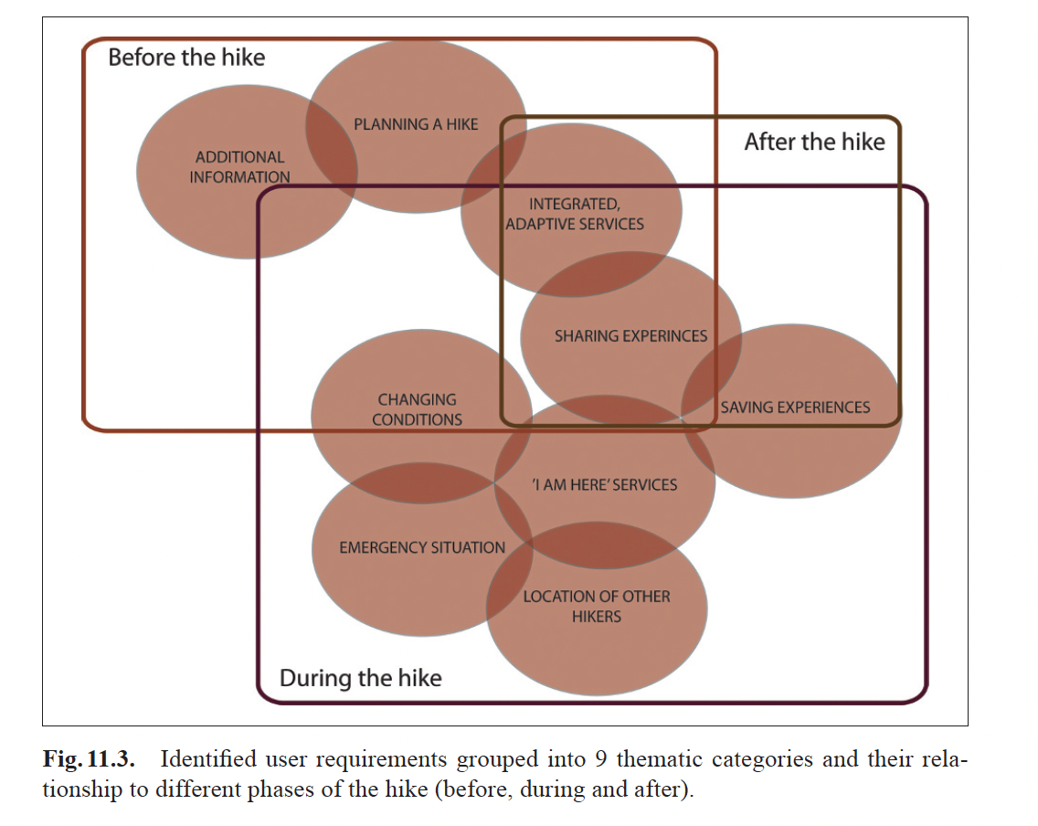

**Article name: Opportunities in Conflict on the Trail**

**Book: HCI outdoors theory design method**

HCI outdoors: Theory, design, methods and applications. (2020). *Human–Computer Interaction Series*. <https://doi.org/10.1007/978-3-030-45289-6>

**Measures:**

* who uses trails, what technology they use, and their attitudes toward the usage of said technologies.

**Tools:**

* organized an initial workshop activity and asked an estimated 25 participants that spanned trail users, trail stakeholders, and researchers on different aspects of the outdoors, to first identify types of trail users on Post-It notes, then to cluster them in subgroups of their choosing.
* GROUP1 workshop session focused on discussing Technology on the Trail

**Article name: Walking: A Grounded Theory of Social Engagement and Experience**

Asimakopoulos, S., & Dix, A. (2017). Walking: A grounded theory of social engagement and experience. *Interacting with Computers*, *29*(6), 824–844. <https://doi.org/10.1093/iwc/iwx014>

**Measures:**

* We describe a grounded theory (GT) framework concerned with the social engagement process central to the experience of walking.
* We provide empirical evidence from data gathered during a 102-day walk of the second author around Wales. We apply the Glaser approach techniques of GT to elaborate the social engagement transition and experience of walking.
* The framework culminates in four main themes: accuracy of social judgements, need for decision accountability, enhancing self-esteem and satisfaction of intrinsic motivation goals. We found that apparently ‘solitary’ walking is set within a rich technical and social matrix.
* We aim to extend the framework for other types of interactive systems, in particular ubiquitous and wearable devices for activity tracking and health applications.

**Tools:**

* the current study employed the Glaser version, also known as Pure GT
* The methodology for this study was chosen due to (i) focusing on walk-ing experience interactions and behaviors of social engagement and (ii) offering a ‘fresh perspective on a well-known area’ (Stern, 1994) by articulating HCI works regard-ing social engagement and the social experience of walking.
* GT analysis was performed independently by the ﬁrst author, with the second author acting effectively as data subject
* Using SPOT live tracker to watch movement

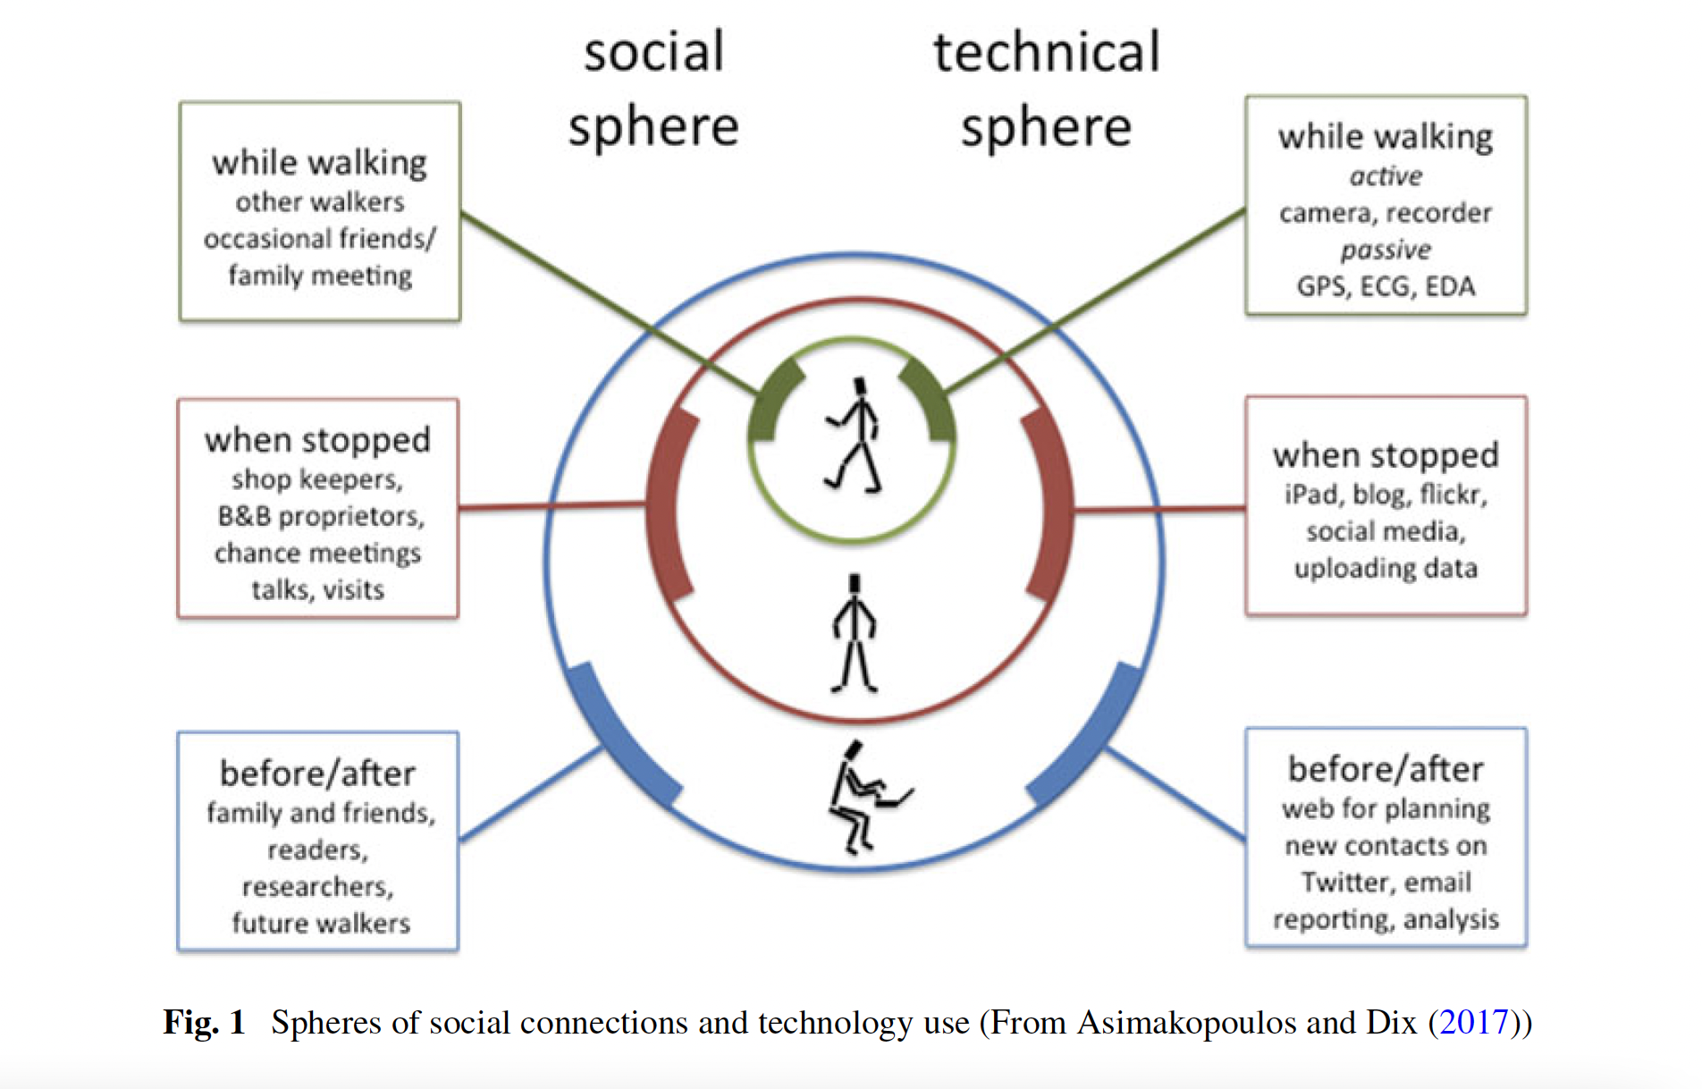

**Article name: The long-distance hiking social world along the Pacific Crest**

Virginia Tech. (2018). *Using K-mode clustering to identify personas for technology on the trail* (dissertation).

**Measures:**

* understand different approaches and perspectives of hikers, with a focus on technology use

**Scales:**

* using 6 Cluster characteristics we created 5 Personas

**Tools:**

* Questionnaires sectioned into three types, single-answer multiple-choice questions, multiple-answer multiple-choice questions, and dichotomous.
* For analysis: K-Mode clustering Algorithm with K = 6 for the complete data

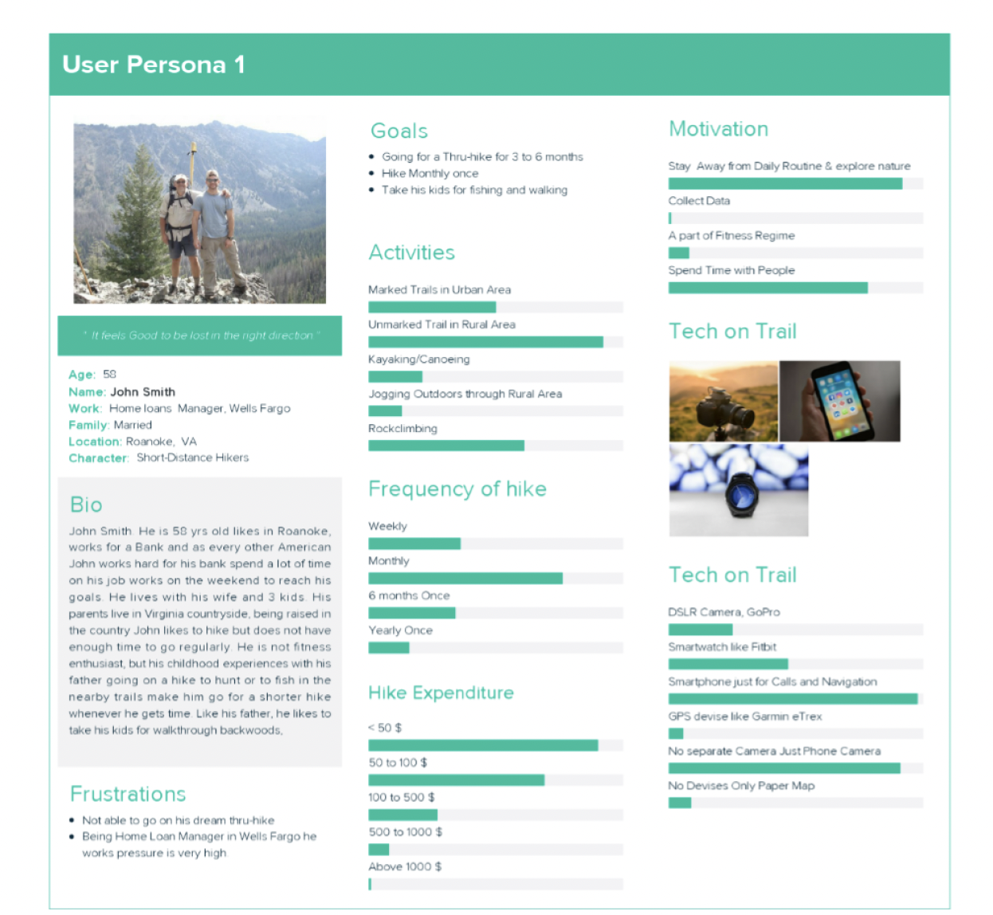

(c) Measures of social experiences on the trail

**Article name: The long-distance hiking social world along the Pacific Crest**

Lum, C. S., Keith, S. J., & Scott, D. (2019). The long-distance hiking social world along the Pacific Crest Trail. *Journal of Leisure Research*, *51*(2), 165–182. <https://doi.org/10.1080/00222216.2019.1640095>

**Measures:**

* Types of hikers: day hikers and multiday hikers
* Pursuits: romantic and utilitarian
* Typologies of hikers

**Tools:**

* naturalistic inquiry (Salkind, 2010), an approach in which we observed, described, and interpreted experiences of individuals within the social world of hikers along the PCT
* Observation (45 days of hiking)
* Field notes
* Interview

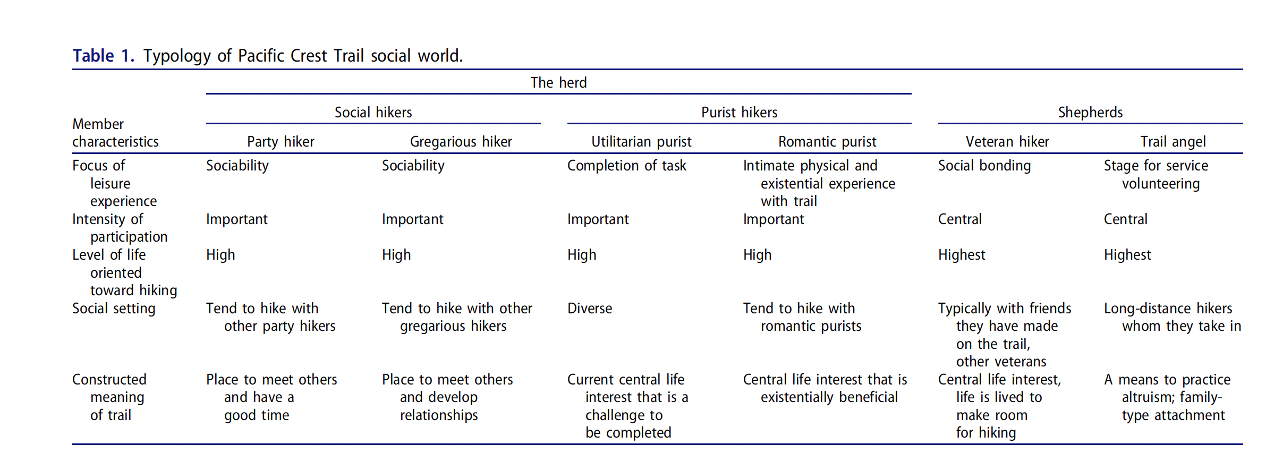

**Article name: An examination of the relationship between leisure activity involvement and place attachment among hikers along the Appalachian Trail**

Kyle, G., Graefe, A., Manning, R., & Bacon, J. (2003). An examination of the relationship between leisure activity involvement and place attachment among hikers along the Appalachian Trail. *Journal of Leisure Research*, *35*(3), 249–273. <https://doi.org/10.1080/00222216.2003.11949993>

**Measures:**

* 3 dimensions on activity involvement; self-expression, centrality and place attachment, were measured using items adapted from McIntrye and Pigram (1992) measure of involvement with hiking
* For place attachment, 8 items measured 2 dimensions; place identity and place dependence
* The effect of use type on relationship between activity involvement and place attachment

**Scales:**

* The alpha values for all constructs ranged between .6 through .93

**Tools:**

* Covariance structure analysis using LISREL (linear structural relations) was used to simultaneously test the model for 4 types of hikers
* Respondents in the study were asked to indicate their type of use; a-day hiker, b-overnight hiker, c-section hiker, d-thru hiker

